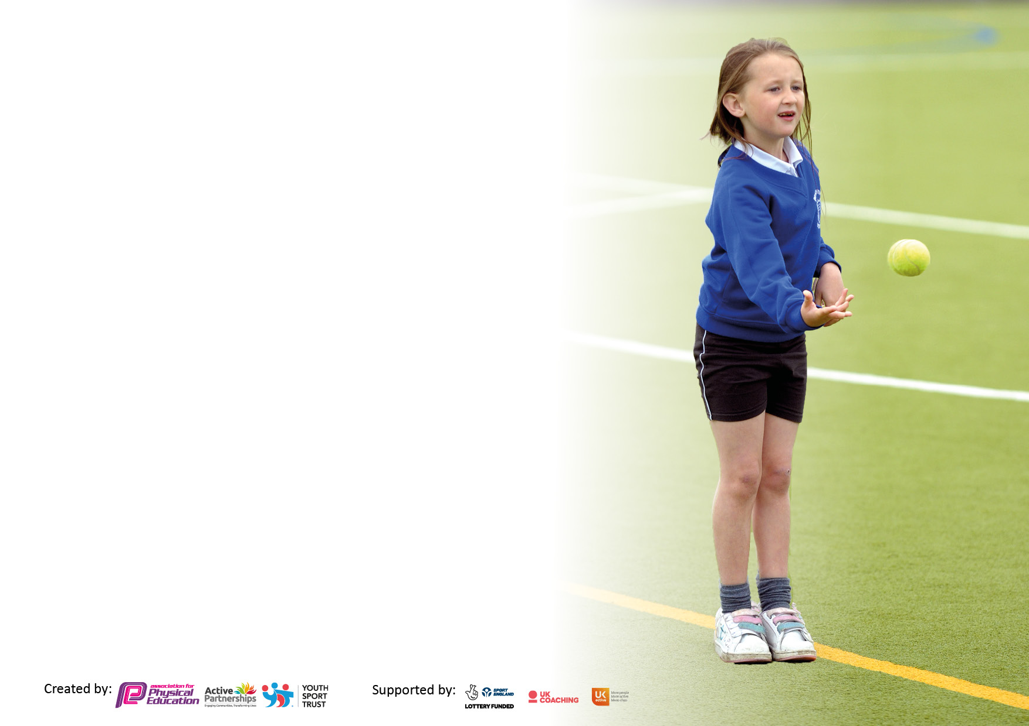

It is important that your grant is used effectively and based on school need. The [Education Inspection Framework](https://www.gov.uk/government/publications/education-inspection-framework) makes clear there will be a focus on **‘whether leaders and those responsible for governors all understand their respective roles and perform these in a way that enhances the effectiveness of the school’**.

Under the Quality of Education judgement, Ofsted inspectors consider:

**Intent** - Curriculum design, coverage and appropriateness

**Implementation** - Curriculum delivery, teaching (pedagogy) and assessment

**Impact** - Attainment and progress

To assist schools with common transferable language, this template has been developed to utilise the same three headings which should make your plans easily transferable between working documents.

Schools must use the funding to make additional and sustainable improvements to the quality of Physical Education, School Sport and Physical Activity (PESSPA) they offer. This means that you should use the Primary PE and sport premium to:

* Develop or add to the PESSPA activities that your school already offers
* Build capacity and capability within the school to ensure that improvements made now will benefit pupils joining the school in future years
* The Primary PE and sport premium should not be used to fund capital spend projects; the school’s budget should fund these.

Please visit <https://www.gov.uk/guidance/pe-and-sport-premium-for-primary-schools> for the revised DfE guidance, including the 5 key indicators across which schools should demonstrate an improvement. This document will help you to review your provision and to report your spend. DfE encourages schools to use this template as an effective way of meeting the reporting requirements of the Primary PE and Sport Premium.

We recommend you start by reflecting on the impact of current provision and reviewing the previous spend.

Schools are required to publish details of how they spend this funding, including any underspend from 2021/2022, as well as on the impact it has on pupils’ PE and sport participation and attainment.

We recommend regularly updating the table and publishing it on your website throughout the year. This evidences your ongoing self-evaluation of how you are using the funding to secure maximum, sustainable impact. Final copy must be posted on your website by the end of the academic year and no later than the 31 July 2023.

**Details with regard to funding**

Please complete the table below.

|  |  |
| --- | --- |
| Total amount carried over from 2021/22 | £2,501 |
| Total amount allocated for 2022/23 | £18,210 |
| How much (if any) do you intend to carry over from this total fund into 2023/24? | £0 |
| Total amount allocated for 2022/23 | £18,210 |
| Total amount of funding for 2022/23 to be reported on by 31st July 2023 | £20,711 (We spent £20,952) |

**Swimming Data**

Please report on your Swimming Data below.

|  |  |
| --- | --- |
| Meeting national curriculum requirements for swimming and water safety.  **N.B.** Complete this section as best you can. For example, you might have practised safe self-rescue techniques on dry land which you can then transfer to the pool when school swimming restarts.  **Due to exceptional circumstances priority should be given to ensuring that pupils can perform safe self-rescue even if they do not fully meet the first two requirements of the NC programme of study** |  |
| What percentage of your current Year 6 cohort swim competently, confidently and proficiently over a distance of at least 25 metres?  **N.B.** Even though your pupils may swim in another year, please report on their attainment on leaving primary school at the end of the summer term 2023.  Please see note above | 51% |
| What percentage of your current Year 6 cohort use a range of strokes effectively [for example, front crawl, backstroke and breaststroke]?  Please see note above | 42% |
| What percentage of your current Year 6 cohort perform safe self-rescue in different water-based situations? | 40% |
| Schools can choose to use the Primary PE and sport premium to provide additional provision for swimming, but this must be for activity **over and above** the national curriculum requirements. Have you used it in this way? | Yes/No |

**Action Plan and Budget Tracking**

Capture your intended annual spend against the 5 key indicators. Clarify the success criteria and evidence of impact that you intend to measure to evaluate for pupils today and for the future.

|  |  |  |  |  |
| --- | --- | --- | --- | --- |
| **Academic Year:** 2022/23 | **Total fund allocated:** | **Date Updated:** | |  |
| **Key indicator 1:** Increase confidence, knowledge and skills of all staff in teaching PE and sport | | | | Percentage of total allocation: |
| % |
| **Intent** | **Implementation** | | **Impact** |  |
| Your school focus should be clear on what you want the pupils to know and be able to do. What do they need to learn and to consolidate through practice: | Make sure your actions to achieve are linked to your intentions: | Funding allocated: | Evidence of impact:  What do pupils now know and what can they now do? What has changed? | Sustainability and suggested next steps: |
| Raise the quality of learning and teaching in PE and school sport by providing support to deliver broad, balanced and inclusive high-quality PE and school sport provision (within and beyond the curriculum) to raise pupils’ attainment. | Staff confidence in delivering PE lessons was discussed in September showing that 6/9 of teaching staff were confident in teaching all areas of the PE curriculum  Provide opportunities for staff to access CPD opportunities through the Christchurch School Sport Partnership CPD programme, team teaching, staff inset and staff meetings.  Use specialist coaches and providers for team teaching & staff training to increase the knowledge and confidence of staff in delivering PE.  Purchase quality assured resources to support teachers and support staff. | £10,002.98  Liz Roberts | Following staff CPD and training to increase confidence, knowledge and skills our most recent staff survey showed that 9/9 of staff are now confident in teaching all areas of the PE curriculum.  - Increased staff knowledge and understanding  - All teachers able to confidently plan, teach and assess National Curriculum PE, using CompletePE  - More confident and competent staff evidenced through feedback and team teaching  - Enhanced quality of provision  - Increased pupil participation in competitive activities and festivals from last year.  There were 187 children participating last year. This year there were: 222 across KS1 and KS2.  - Increased range of opportunities  - The sharing of best practice with other schools in the Christchurch Learning Partnership.  - A more inclusive curriculum through CompletePE which inspires and engages the majority of the pupils in 7/9 classes. In the 2 year 6 classes there has been less impact due to some challenging behaviour in the classes.  - Increased capacity and sustainability | Review staff confidence and competence in delivering high quality PE and school sport and allocate staff to upcoming CPD opportunities.  PE Co-Ordinator to carry out a learning walk next year. |
| **Key indicator 2:** The engagement of all pupils in regular physical activity – Chief Medical Officers’ guidelines recommend that  primary school pupils undertake at least 30 minutes of physical activity a day in school | | | | Percentage of total allocation: |
| % |
| **Intent** | **Implementation** | | **Impact** |  |
| Your school focus should be clear on what you want the pupils to know and be able to do. What do they need to learn and to consolidate through practice: | Make sure your actions to achieve are linked to your intentions: | Funding allocated: | Evidence of impact:  What do pupils now know and what can they now do? What has changed? | Sustainability and suggested next steps: |
| Improve physical activity levels in our most inactive pupils:  Outline any actions here. For example:   * Daily physical activity initiatives, such as, the Daily Mile, active learning. * Training sports leaders/Bronze Ambassadors * Training TAs and lunchtime staff to engage learners in active play at lunchtimes * Purchase quality equipment to be used to increase daily physical activity * Playground markings to provide activity and fitness ideas   Ensure maximum uptake of our extra-curricular clubs to engage as many pupils in extra curricular clubs as possible. | - As a school we contribute funding to sustain the Christchurch School Sport Partnership which provides the following opportunities:   * Complete PE * Youth Sport Trust Primary Membership * Additional competitions outside of the School Games programme * Comprehensive CPD programme * PE Conference * Dance project and festival * Outdoor activity days * Primary Leadership Academy * Christchurch Sports Awards * Support from partnership lead for team teaching and staff training.   Develop a team of sports leaders & Bronze Ambassadors through the Christchurch Primary Leadership Academy. Use the Dorset leadership awards to support pupils on their leadership pathway. | £5,650  Premier Education  £420  Minibus hire to attend local events.  £130  Dance workshop and scarves | Premier Education run a lunchtime club (twice a week in KS1 and KS2) to target the least active pupils. At least 20 pupils per session have attended these clubs, with a lot coming from the least active group. The pupils from the inactive group are now accessing the CMO guidelines.  Increase in many pupils meeting CMO guidelines  Clubs delivered as lunchtime and after school depending on demand. Average attendance at clubs is 20 children per club.  Increase in the number of pupils attending extra curricular clubs as we now have more clubs running. | Continuously monitor physical activity levels and identify the most appropriate target groups to achieve maximum impact.  Use Christchurch PE Conference to review, evaluate and plan for the next academic year.  Sports Leaders to target least active groups in KS1 during lunchtimes. |

|  |  |  |  |  |
| --- | --- | --- | --- | --- |
| **Key indicator 3:** The profile of PE and sport is raised across the school as a tool for whole school improvement | | | | Percentage of total allocation: |
| % |
| **Intent** | **Implementation** | | **Impact** |  |
| Your school focus should be clear on what you want the pupils to know and be able to do. What do they need to learn and to consolidate through practice: | Make sure your actions to achieve are linked to your intentions: | Funding allocated: | Evidence of impact:  What do pupils now know and what can they now do? What has  changed? | Sustainability and suggested next steps: |
|  |  |  |  |  |
|  |  |  |  |  |
|  |  |  |  |  |
|  |  |  |  |  |
| Develop teacher’s skills and knowledge in activities that will engage and inspire our pupils to take part in life long physical activity.  Engage learners in new a different experiences such as new sports and new experiences with local providers.  Re-engage all learners in partnership events calendar. Work to achieve School Games Mark by recognising and encouraging the continued increase of inclusive sport and physical activity for all learners. | Use Sports Premium where appropriate to provide training, experiences and transport to access.  Identify pupils who are not members of community clubs and facilitate their transition to a community club, whether as a player or volunteer. Links with Liz Roberts. | £2,250  Climbing wall and cave | High quality lessons delivered in engaging activities. Happy engaged pupils.  Teachers delivering high quality lessons. Pupils engaged in competitions, extra-curricular and community clubs following sessions. Links with Phoenix Handball Club to increase participation of children after school. At the moment we have 17 children from KS2.  Increase in at least 50% pupils accessing extra-curricular clubs | Develop any links with community clubs. |
| **Key indicator 4:** Broader experience of a range of sports and physical activities offered to all pupils | | | | Percentage of total allocation: |
|  |
| **Intent** | **Implementation** | | **Impact** |  |
| Your school focus should be clear on what you want the pupils to know and be able to do. What do they need to learn and to consolidate through practice: | Make sure your actions to achieve are linked to your intentions: | Funding allocated: | Evidence of impact:  What do pupils now know and what can they now do? What has  changed? | Sustainability and suggested next steps: |
|  |  |  |  |  |
|  |  |  |  |  |
|  |  |  |  |  |
|  |  |  |  |  |
| Identify which activities pupils would like to try by year group, gender and least active groups. Ensure our school are providing activities that will engage the most pupils as well as the least active.  Provide opportunities to take part in a diverse range of school sport through extra-curricular clubs, competitions and events.  Develop opportunities for pupils to access community sport in order to develop social skills, leadership and communication outside of school. | Provide opportunities for children with SEND, the least confident and the least active to attend exciting, varied and a new range of activities through the school sport partnership.  *3 x Dare to Believe festivals (30 children), sports leader training (40 children), 2 x outdoor education challenge days at Moors Valley Country Park (12 children), 2 x Netball tournaments (28 children), Girls football (9 children) 3x Handball (30 children} Common wealth Games (10 children) Multi skills (10 children) Cricket (10 children) Can do festival (8 children) Tri golf (10 children) Step into sport (10 children)*  Review extra-curricular activities through pupil voice/Bronze Ambassadors.  Employ sports coaches to provide appropriate extra-curricular sporting opportunities and to improve sports skills in children through increased opportunities in school and the wider community  Complete inclusive health check on the School Games Website to review our PE and school sport offer in terms of inclusion and use the action plan to develop our offer. | Premier Education coaches;  See above | Registers from additional clubs have an average attendance of 20 pupils after school and 20 children during 2 lunchtimes.  Increase in attendance of extra-curricular clubs, such as, girls and boys football and clubs run by Premier Education and Mr Hockton.  Reduction of pupils not meeting 30 minutes physical activity per day  Increase in pupils attending the Phoenix Handball club. At the moment we have 17 children from KS2 but hopefully, this will increase next year.  Evidence that ALL children in our school are given the same opportunites in PE. | Complete pupil survey to allow student voice to influence our extra-curricular sports programme. |

|  |  |  |  |  |
| --- | --- | --- | --- | --- |
| **Key indicator 5:** Increased participation in competitive sport | | | | Percentage of total allocation: |
| % |
| **Intent** | **Implementation** | | **Impact** |  |
| Your school focus should be clear on what you want the pupils to know and be able to do. What do they need to learn and to consolidate through practice: | Make sure your actions to achieve are linked to your intentions: | Funding allocated: | Evidence of impact:  What do pupils now know and what can they now do? What has  changed? | Sustainability and suggested next steps: |
|  |  |  |  |  |
|  |  |  |  |  |
|  |  |  |  |  |
|  |  |  |  |  |
| Provide opportunities for all children to challenge themselves through both intra and inter school sport where the children's motivation, competence and confidence are at the centre of the competition and the focus is on the process rather than the outcome.  Increased participation in School Games competitions.  Providing opportunities for children with SEND, the least active and the least confident to attend competitions and events.  Select children who we feel would benefit most from the opportunities available in the Christchurch Partnership events calendar. | Engage with School Games Organiser and attend competitions run by the Christchurch School Sport Partnership.  *3 x Dare to Believe festivals (30 children), sports leader training (40 children), 2 x outdoor education challenge days at Moors Valley Country Park (12 children), 2 x Netball tournaments (28 children), Girls football (9 children) 3x Handball (30 children} Common wealth Games (10 children) Multi skills (10 children) Cricket (10 children) Can do festival (8 children) Tri golf (10 children) Step into sport (10 children)*  Engage more staff/parents/volunteers and young leaders to support attendance at competitions.  Use external coaches to run competitions to increase pupils’ participation. | Christchurch Sports Partnership  £2,500 | Use external coaches to run competitions to increase pupils’ participation. | Review attendance data and identify children for appropriate opportunities.  Engage more staff/parents/volunteers and young leaders to support attendance at competitions.  Continue to monitor % of pupils representing school in competitive sport and allow us to identify those that have not.  Continue to attend Christchurch Partnership half-termly meetings to help shape the offer to ensure it is appropriate for our pupils and of the highest quality. |

|  |  |
| --- | --- |
| Signed off by | |
| Head Teacher: |  |
| Date: |  |
| Subject Leader: |  |
| Date: |  |
| Governor: |  |
| Date: |  |