Water, Water Everywhere! KNOWLEDGE ORGANISER

VOCABULARY |  |  |  | VOCABULARY
albatross |  | Large bird with long narrow wings |  | fissures |  | Narrow opening or crack of considerable length
anguish |  | Great mental or physical pain
authority |  | A power or right to give orders.
bewildered |  | Great confusion- very puzzled
blighted |  | To destroy
collided |  | Forceful impact
composure |  | Ability to stay calm
crescendo |  | Loudest point reached
cascaded |  | Pour downwards rapidly
dinghy |  | A small inflatable boat
distraught |  | Someone who is very troubled, confused or has gone crazy
flimsy |  | Weak inadequate
OLIVER AND THE SEAWIGS KNOWLEDGE ORGANISER

A RIVERS COURSE: RIVER’S COURSE:

VOCABULARY |  |  |  | VOCABULARY
River | 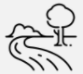 | a flowing, moving stream of water. |  | tributary |  | A small river or stream that meets a large river
stream |  | a small, fast flow of water |  | mouth |  | where the river enters the sea
canal | 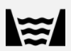 | waterways built by people used for shipping and transport |  | confluence |  | where two rivers meet
reservoir |  | the store of water that is help back by the dam |  | meander |  | a winding bend in the river
lake | 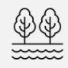 | large bodies of water that are surrounded by land and not part of an ocean. |  | estuary |  | the last section of the river before the sea
sea |  | a huge body of salt water |  | Water cycle | 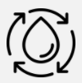 | the journey of water on the earth
source | 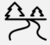 | where a river begins its journey |  | ocean | 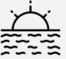 | a very large expanse of sea
channel | 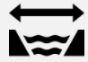 | the path of a river |  | water | 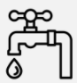 | a colourless, odourless liquid that forms the seas, lakes, rivers
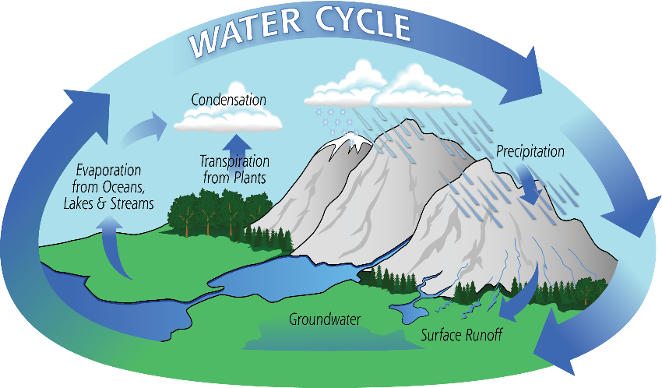
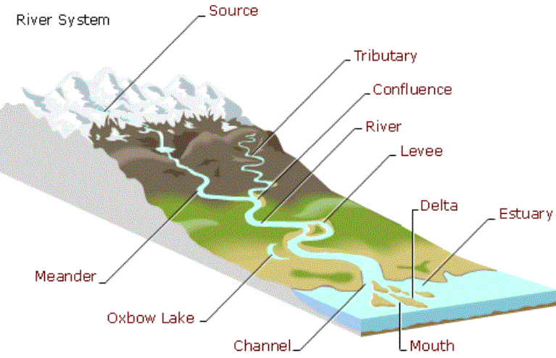
THE WATER CYCLE:

